**Musician’s page**

**Aquapella**

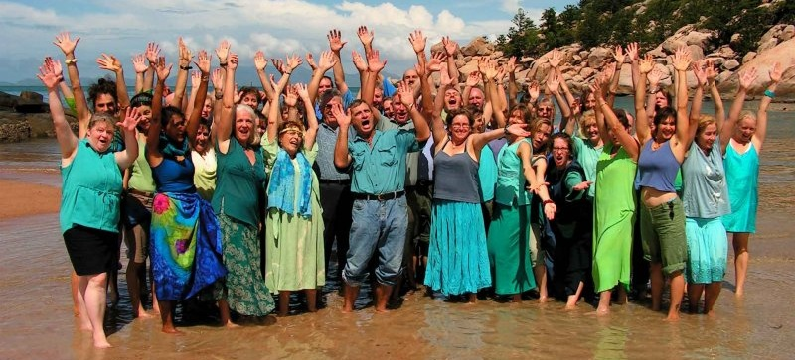

The Aquapella are a group of 50 singers from the Townsville area bringing you a cappella world music at its very best: inspiring and uplifting harmonies from around the globe.

Some songs that they sing are;

* A South African party song
* A Hungarian love triangle
* "The Lion Sleeps Tonight" in French - a sumptuous variety of different languages, stories, rhythms and moods to entertain and move you in the wonderful common language of music.

Come along and travel the world by song!

For further information email beatlehmann@iprimus.com.au

**Aviva Quartet**

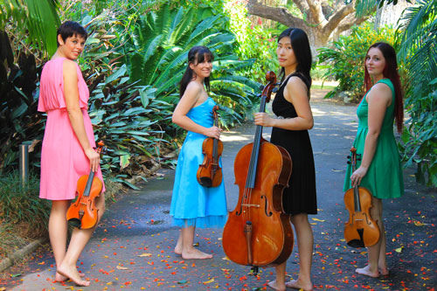

Are four talented musicians that combine their skills in a variety of musical styles including fiery Rhumbas, Tangos, Serenades - a mixture of the most devine and swoon-worthy pieces, guaranteed to delight the senses.

The girls all have a passion for chamber music and are very excited to be able to form up a group that will be able to perform regularly both locally and in the surrounding regions. Their concert will take listeners through a wonderful journey of beautiful melodies and the most romantic music that is guaranteed to leave the senses fulfilled and wanting more.

For more information - Phone 07 4724 2086 Mobile 0402 255 182 e-mail admin@townsvillemusic.org.au

**The Camerata Singers**

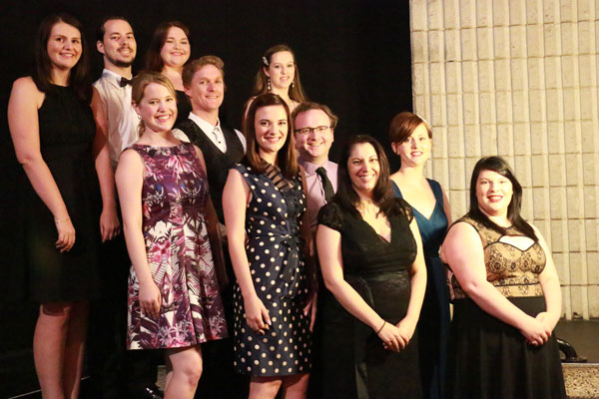

The Camerata Singers originated in the 1980s when Susan Grinsell, who was teaching voice at James Cook University realised that ensemble singing was sadly lacking for tertiary music students.

The Camerata Singers comprises a group of trained singers, both male and female, from age 18 and over who strive to provide quality performances in a range of styles from classical through to A cappella and contemporary. A number of members also regularly participate in local music theatre and theatre productions.

For further information or bookings contact the Music Centre 4724 2086 or email admin@townsvillemusic.org.au

**Celtic Fyre**

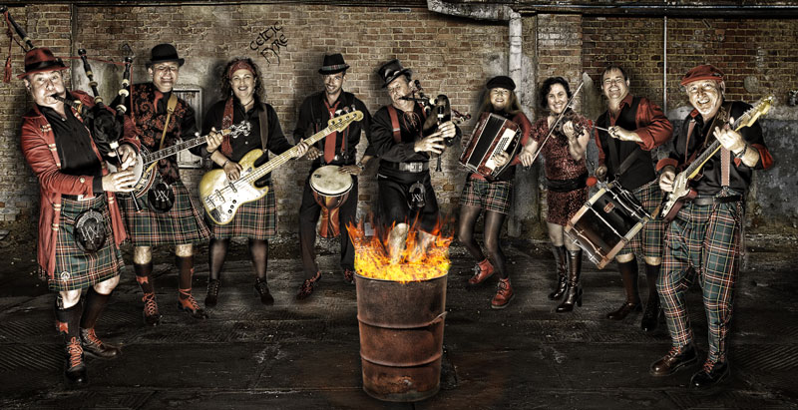

Celtic Fyre The alternative celtic rock band from North Queensland. A typical audience response: - "WOW - I wasn't prepared for that! Racing around the stage in kilts, blowing bagpipes, jumping from one instrument to the next, these guys know how to entertain!"

t is an 11-piece band that is a fun-loving kick-em-in-the-pants band that just wants to rock - celtic style!

For further information visit www.celticfyre.com

**Dirty Dozen**

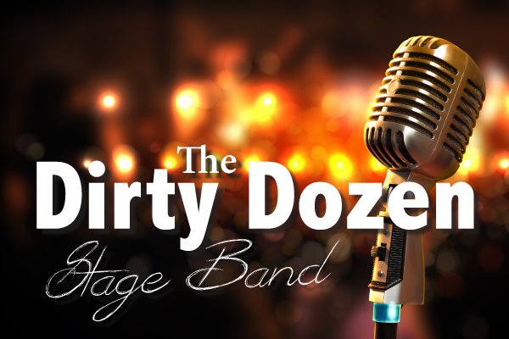

Townsville's dynamic 12-piece Stage Band! They play jazz, rock, blues and modern top-40 songs featuring vocalists, trumpets, saxophones, trombone, drums, piano/keyboard and guitars.

Some songs they play;

* It Don't Mean a Thing
* Mustang Sally
* Spinning Wheel
* Moondance
* In the Midnight Hour
* Le Belleclaire Blues
* Lady Madonna
* Skyfall
* Shake a Tail Feather
* Soul Man
* Peter Gunn
* Minnie the Moocha
* Sweet Home Chicago
* R.E.S.P.E.C.T.
* Everybody
* Leave Your Hat On
* Superstition
* The Letter
* Proud Mary
* Knock on Wood
* I Got You
* ROCK in the USA
* December 1963 (Oh What a Night!)
* Don't Know Why
* Walkin' on Sunshine

For further information contact Andi Hodgson 0421 072 625

**Harbourside Duo**

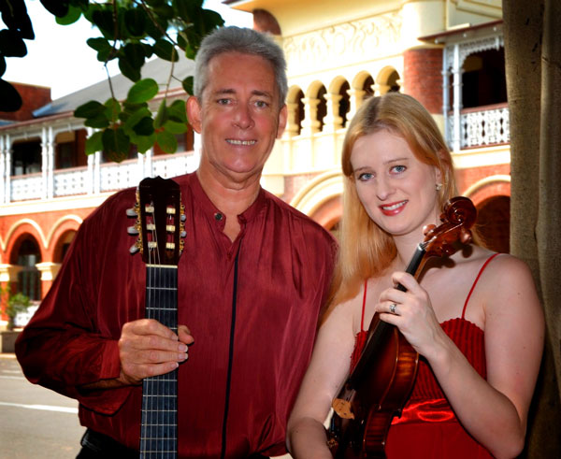

The Harbourside Duo is a new ensemble performing in Townsville and North Queensland featuring Monica Martin on Violin and David Roberts on Classical Guitar. They perform a fine selection of music from Latin, Jazz, Celtic, Classical and popular styles. The Harbourside Duo is available for Corporate Functions, Weddings and private gatherings.

For further information or bookings contact David Roberts 0459 239 290 Visit [www.davidrobertsguitar.com.au/Harbourside-Duo.html](http://www.davidrobertsguitar.com.au/Harbourside-Duo.html)

**Poms from Oz**

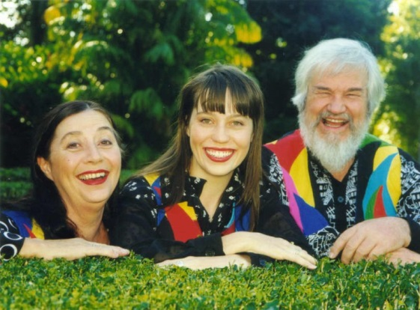

Poms from Oz are a family of solo vocalists from North Queensland, Australia. Their tight harmony and vocal strength bring a fresh feel to original, contemporary and traditional works, uncovering a rich tapestry of songs gathered in their travels from around the world. Most of their songs are acappella but sometimes are accompanied by guitar or harmonica. Moods in their songs range from downright to real tear jerkers and audience participation is encouraged.

For further information or bookings contact the Music Centre 4724 2086 or email admin@townsvillemusic.org.au

**Rosewood Guitar Quartet**

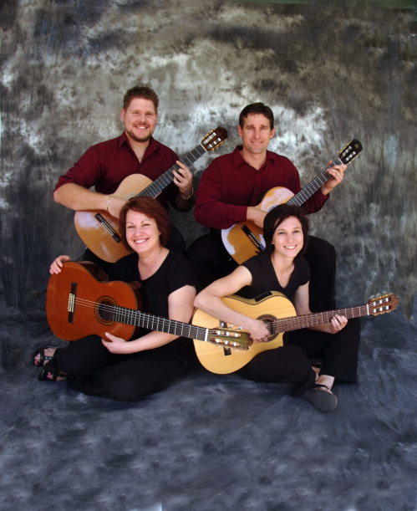

The Rosewood Guitar Quartet adds some elegance to your next social event! Have the Rosewood Guitar Quartet provide that special atmosphere by playing for your guests Sample CD available on request.

For further information phone: 0427 255 125

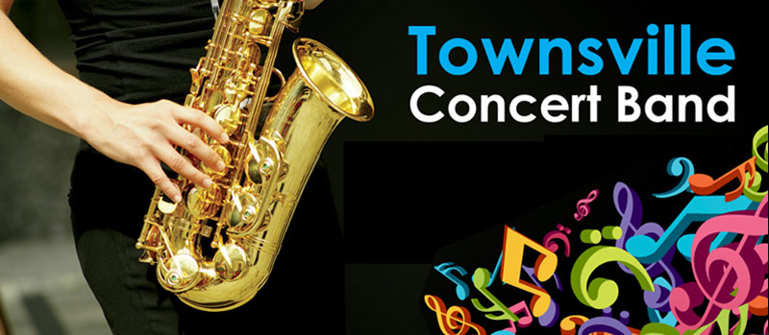

The Townsville Concert Band is a local community band who play gigs around town thought out the year. They play a range of different styles of concert band music, ranging from classical to musical theatre and modern.

The Townsville Concert Band is currently looking for musician members. All levels and ages are welcome.

For more information email us hollie.clark1@jcu.edu.au or phone Hollie: 04019 151 185 or phone Mark: 0408 088 675. Also check us out on facebook.

**Wassa**

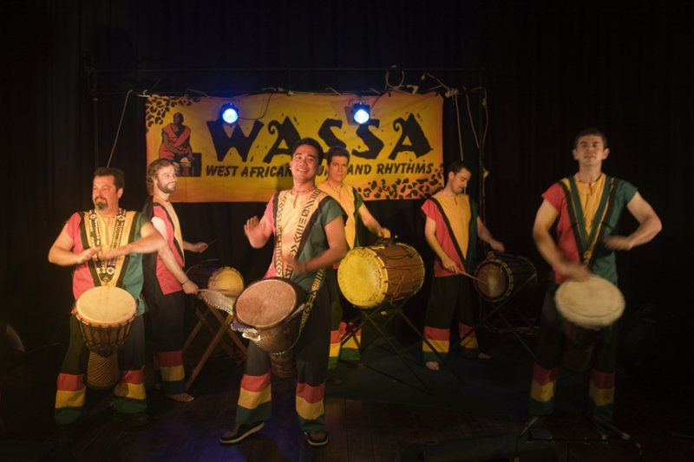

Wassa is a six-piece percussion group that perform traditional rhythms from West Africa on traditional instruments.

The Townsville based group has been performing throughout North Queensland and as far as Papua New Guinea since 2001.

For further information visit http://www.therhythmconnection.com/wassa.html

**Stokes-Nicholson Big Band**

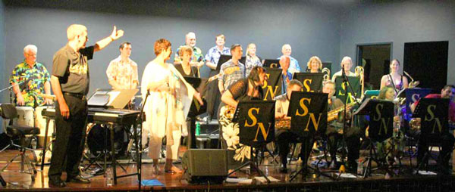

The Stokes-Nicholson Big Band was formed in 199 by Roy Stokes and Les Nicholson. Roy wanted to create an opportunity to keep experienced musicians playing challenging music so their talents didn't go rusty. Les came from a different perspective of wanting to provide an opportunity for music students of all ages to sit beside experienced jazz musicians. The Stokes Nicholson Big Band was meeting once a month for rehearsals.

Sadly Roy passed away on 1st January 1993 after a period of illness. Les continued to manage the band and conduct rehearsals, as well as playing first trumpet. In 1997 he enlisted the help of John Ruffle who took on the role of Musical Director, allowing Les to relax a little.

The band today demonstrates it has achieved the aims of both Roy and Les with experienced musicians arriving in town and feeling very proud to join such a powerful big band. A number of the original student members from 1991 are still in the band and have now joined the ranks of the experienced musicians and new students are still progressing from school bands to the Stokes Nicholson Big Band.

For more information contact Les Nicholson on 0417 637 893